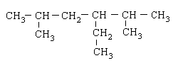________________________________________________

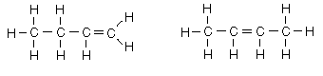

_________________________________________________________________________________

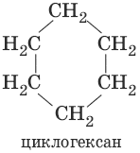 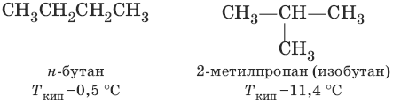

_________________________________________________________________________________

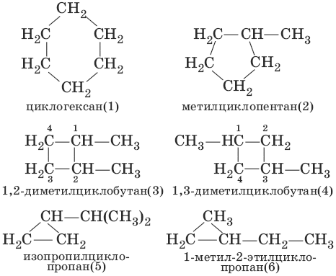 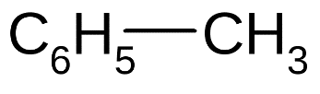

______________________________________________________________________________________

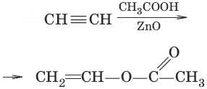

______________________________________________________________________________________



_______________________________________________________________________________________

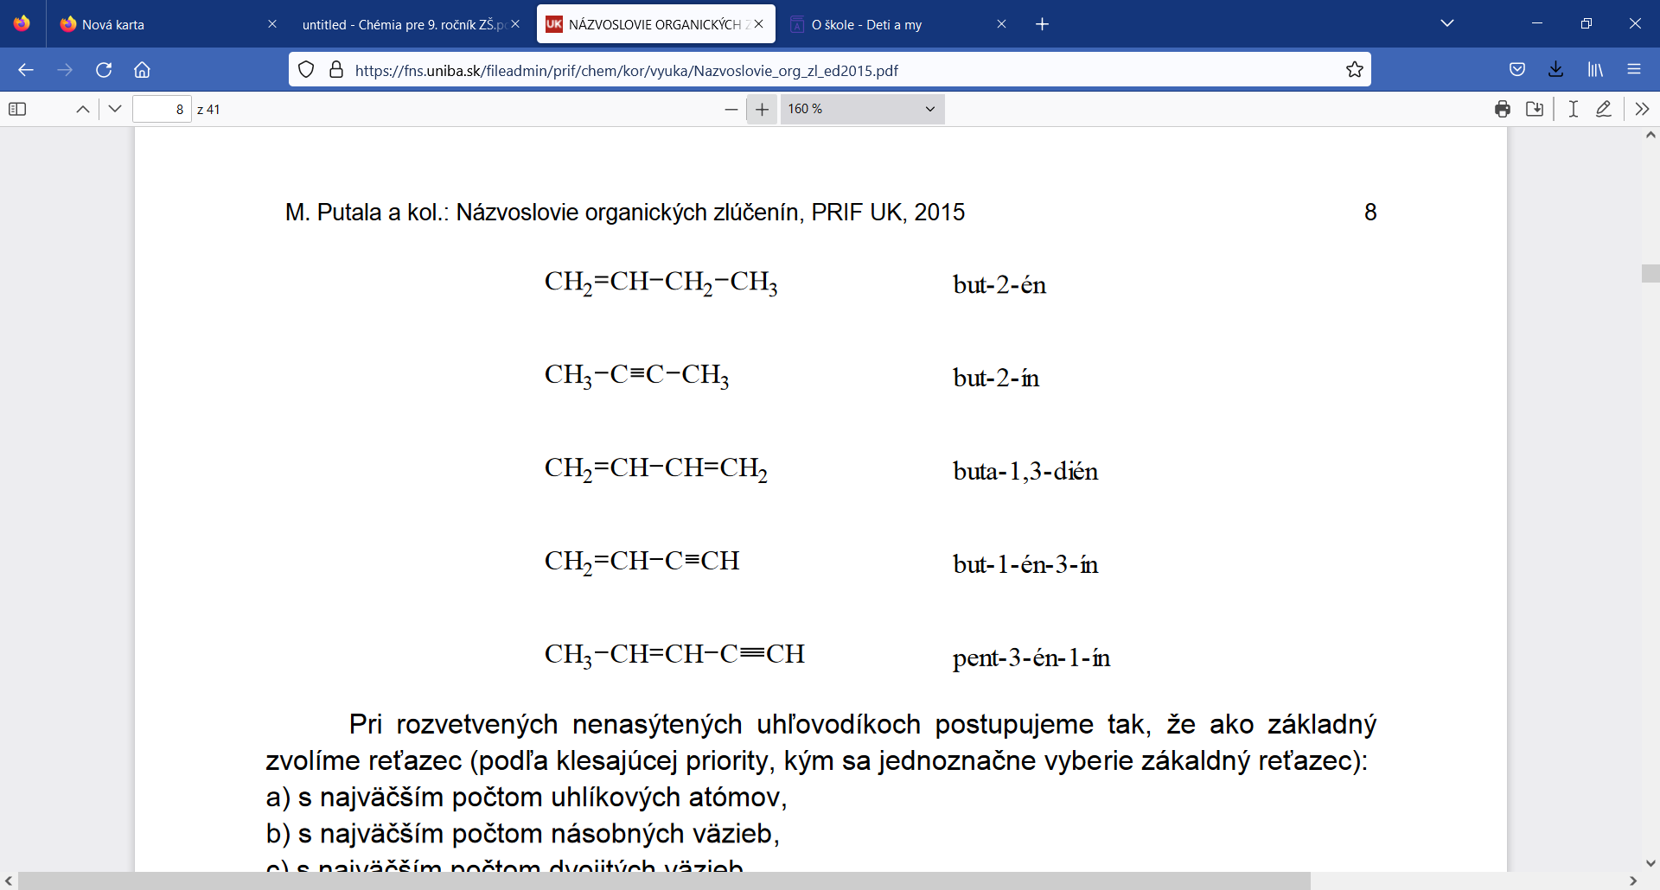

2-metylpropán

2,4-dimetylpentán

2,2-dietylhexán

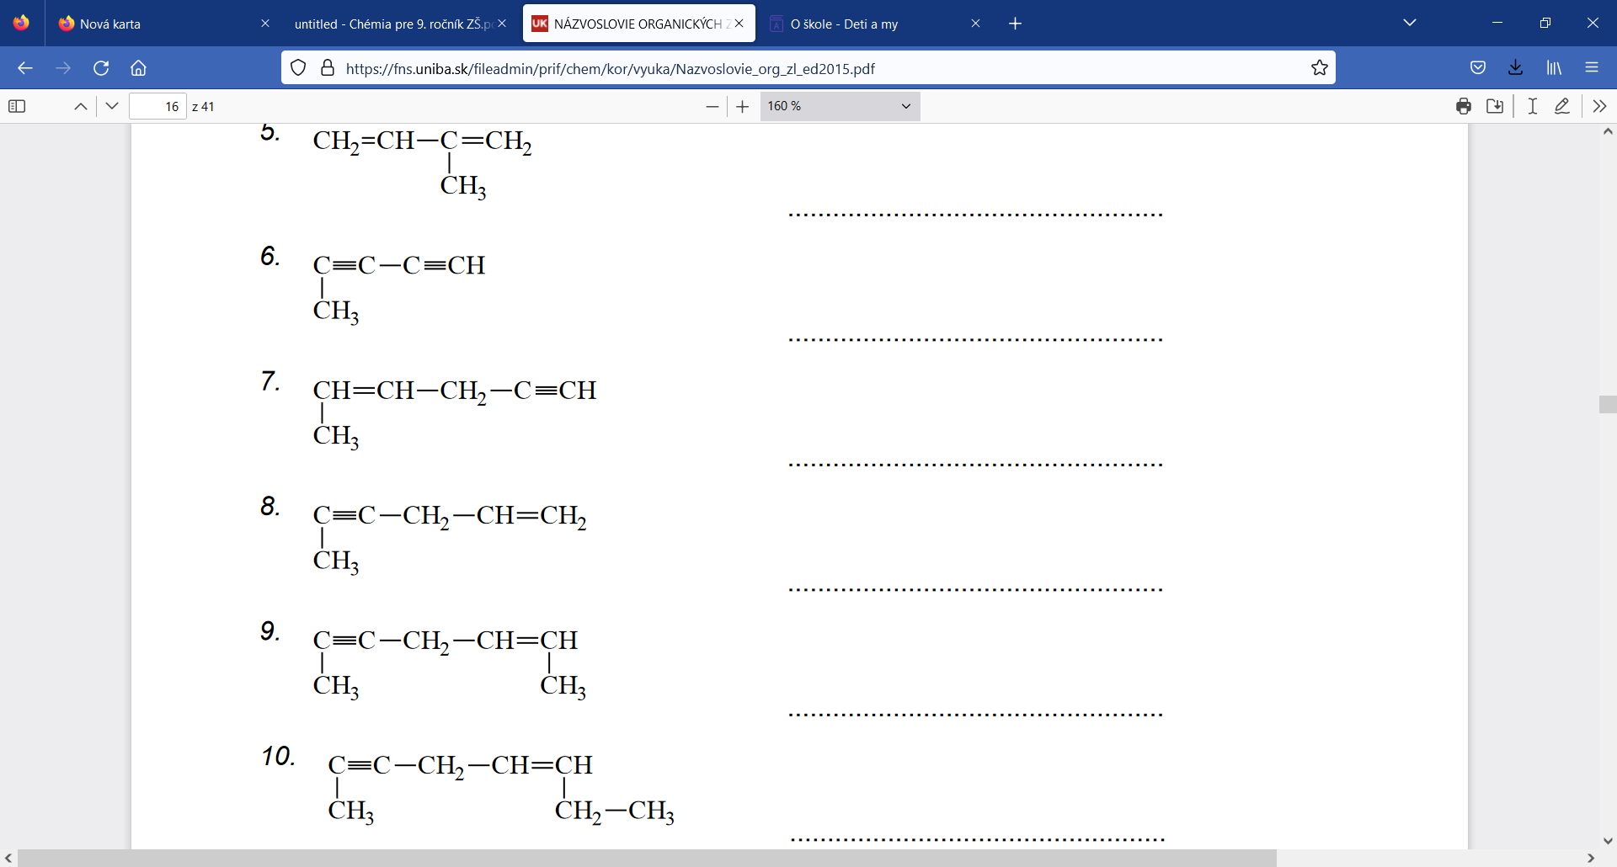

________________________________________________



_________________________________________________________________________________

 

_________________________________________________________________________________

 

______________________________________________________________________________________



______________________________________________________________________________________



_______________________________________________________________________________________



2-metylpropán

2,4-dimetylpentán

2,2-dietylhexán

